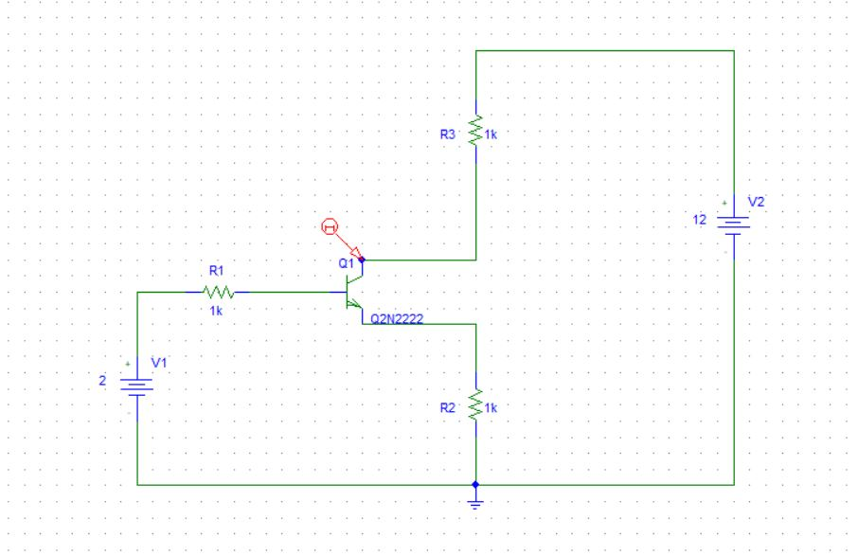

BJT OUTPUT CHARACTERISTICS CURVE CIRCUIT

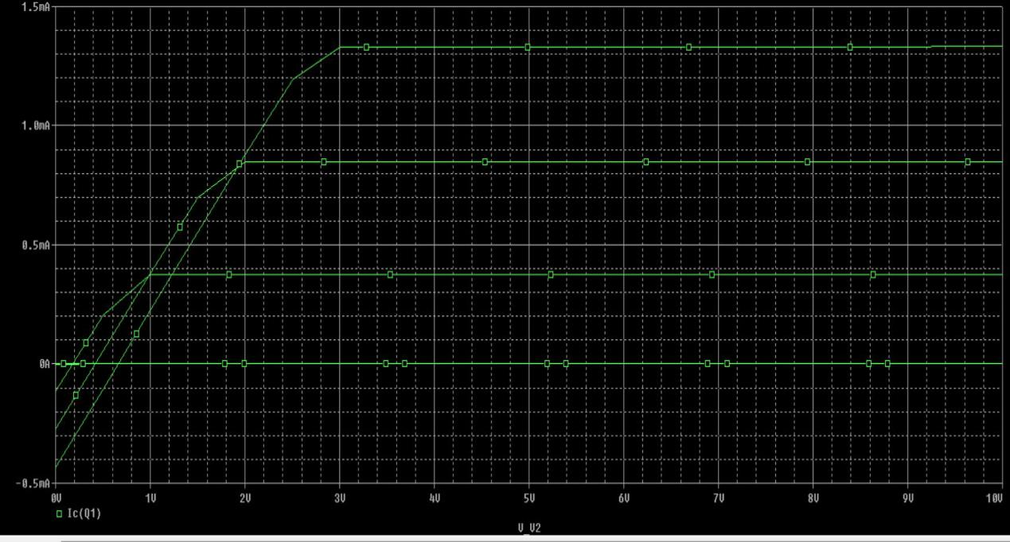

BJT OUTPUT CHARACTERISTICS WAVEFORM